**Feature 1: Health Tracking Module:**

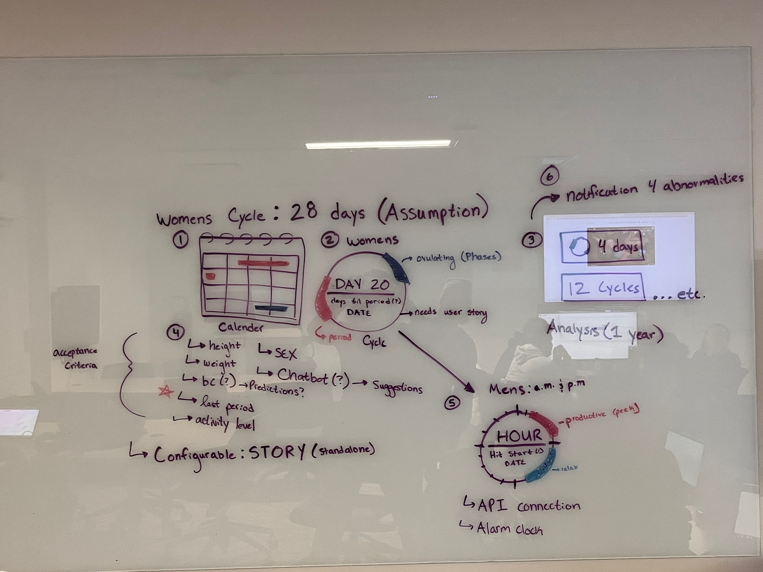

* **User Epic Story 1.1: As a female user, I want to track and monitor my menstrual cycle for reproductive health and fertility planning**.
  + *User Story 1.1.1*: As a female user, I want to enter my menstrual cycle data to predict my upcoming cycle dates
    - Acceptance Criteria / Tasks:
      * An interface with a form where users can enter the following data:
        + Height
        + Weight
        + Birth Control

If yes? Type of BC

* + - * + **Last Period**
        + Activity Level
  + *User Story 1.1.2*: Enable female users to set notifications for upcoming fertile days based on cycle data.
    - Acceptance Criteria / Tasks:
      * Cycle Phase
      * Abnormalities
      * Birth Control Alarm
  + *User Story 1.1.3:* As a female user, I want to be able to view my menstrual cycle through a calendar view
    - Acceptance Criteria / Tasks:
    - Views
      * Calendar View
      * Circular Flow View with phases
      * Analysis View (1 year)
        + # of cycles
        + How long your period is
        + Period Flow
  + *User Story 1.1.4:* As a female user, I want to be able to configure my settings and what I'm able to see
    - Acceptance Criteria / Tasks:
      * “Twitter Feed” Social Feature
      * Education/Teaching
      * Resources
      * Messages Section (AI Chatbot)
* **User Epic Story 2: As a male user, I want to track and monitor my testosterone cycle for health**
  + *User Story 2.1*: As a male user, I want to enter my testosterone cycle data to predict my upcoming cycle dates
    - Acceptance Criteria / Tasks:
      * An interface with a form where users can enter the following data:
        + Height
        + Weight
        + Testosterone enhancements or diminutions
        + Work Schedule
        + Sleep Schedule
        + Health Conditions/medication
        + Age
        + (Optional) Calorie Def, Surplus, Maintenance
  + *User Story 2.2:* Enable male users to set notifications for upcoming fertile time slots in a given day based on cycle data.
    - Acceptance Criteria / Tasks:
      * Dietary
      * What phase you are in
      * Sleep Notifications
      * Daily Questions
        + Ex: your sports team lost
* **User Epic Story 3: Enable users to set notifications for upcoming fertile days based on cycle data.**
  + Period Approaching

1. Implement a user-friendly interface to input menstrual cycle data into the Solid Pods.
2. Develop a backend system to securely store and retrieve menstrual cycle information.
3. Integrate a calendar view for users to visualize their menstrual cycles over time.
4. Ensure data encryption and security protocols are in place for sensitive health information.

* **User Epic Story 2: As a male user, I want to monitor my overall health and fitness metrics using the Solid platform.**
  + Acceptance Criteria / Tasks:

1. Create data entry points for male users to input fitness, diet, and sleep data securely into Pods.
2. Develop backend algorithms to analyze fitness data and generate personalized health insights.
3. Implement a dashboard for visualizing trends in exercise routines, nutrition, and sleep patterns.
4. Enable integration with fitness tracking devices for real-time data updates.
5. Implement data backup and recovery mechanisms to prevent data loss.

**Feature 2: Medical Records Integration:**

* User Story 1: As a female user, I want seamless integration of menstrual cycle data with my electronic health records (EHR).
  + Acceptance Criteria / Tasks:

1. Establish secure APIs for integrating menstrual cycle data with existing EHR systems.
2. Develop data mapping tools to ensure compatibility between Solid Pods and various EHR formats.
3. Enable healthcare professionals to access menstrual cycle data during consultations.
4. Implement audit logs to track access and modifications to health records.
5. Ensure compliance with health data interoperability standards.

* User Story 2: As a male user, I want my health data stored in Pods to be seamlessly integrated with health insurance systems.
  + Acceptance Criteria / Tasks:

1. Collaborate with health insurance providers to define integration requirements.
2. Develop secure APIs for transmitting health data to insurance systems.
3. Implement consent mechanisms for users to control data sharing with insurance providers.
4. Ensure compliance with industry standards for health data exchange.
5. Conduct thorough testing to validate data accuracy and reliability.

**Feature 3: Productivity and Wellness Insights:**

* User Story 1: As a female user, I want insights into how my menstrual cycle affects my mood and productivity.
  + Acceptance Criteria / Tasks:

1. Implement algorithms to correlate menstrual cycle data with mood fluctuations and productivity levels.
2. Create visualizations to represent mood and productivity trends over the menstrual cycle.
3. Provide personalized recommendations for stress management during specific cycle phases.
4. Enable users to journal and track daily activities to enhance mood and productivity analysis.
5. Implement user feedback mechanisms to continuously improve insights accuracy.

* User Story 2: As a male user, I want to receive recommendations for maintaining a work-life balance based on health and productivity data.
  + Acceptance Criteria / Tasks:

1. Analyze work-related tasks and productivity metrics to generate insights.
2. Develop a recommendation engine for suggesting work-life balance improvements.
3. Integrate with calendar systems to provide reminders for breaks and relaxation activities.
4. Implement a feedback loop for users to provide input on the effectiveness of recommendations.
5. Ensure data anonymization when aggregating productivity insights for broader analysis.